Travel Plan
2019-20

School Details

St Mary’s School
47 Fitzjohn Avenue
London
NW3 6PG
Tel: 0207 4351868
Email: office@stmh.co.uk

Headmistress: Harriet Connor-Earl
Deputy Head: Philippa d’Aquino
Director of Studies: Martin Otter

Borough: Camden
DFE number: 202/6084
School type: Roman Catholic Independent Prep School
Age Range: 2years 9months – 11
Number of students: 294
Number of staff: 81

Catchment area
There are 131 children from NW3 area. 54 children live in NW6. 25 from NW8, 11 from NW2. And the remainder from other areas. See chart below.

Post code | Area | 2017 | 2018 | 2019
N1 | Hoxton | 5 | 3 | 4
N10 | Muswell Hill | 3 | 2 | 2
N3&N2 | Finchley | 9 | 6 | 6
N5 | Islington | 3 | 4 | 3
N6 | Highgate | 7 | 3 | 4
N8 | Crouch End | 3 | 2
NW1 | Camden, Regents Park | 2 | 1 | 2
NW10 | Brent, Kensal Green | 7 | 6 | 5
NW11 | Barnet, Childs hill | 13 | 8 | 11
NW2 | Brent | 16 | 11 | 10
NW3 | Camden, Hampstead, Swiss Cottage, Primrose | 125 | 131 | 126
NW6 | Kilburn | 52 | 54 | 56
NW5 | Camden, Kentish Town | 7 | 8 | 11
NW1 | Barnet, Mill Hill | 2 | 0 | 0
NW8 | Westminster | 25 | 25 | 23
N7, N11, N12, N17 |  |  |  | 4
NW9, SE3, W1U, WD3, HA4, I98 |  |  |  | 7
EC1Y |  |  |  | 2
W9 | Westbourne, Westminster | 14 | 13 | 17

Expansion Plans
At present there are no expansion plans for the school. The school is open from 8am until 6pm each day. The school day runs from 8.45 until 4pm. There is a staggered dismissal time for children in R-Y6 between 3.30-4pm. Children from the Pre-Nursery and Nursery have the option of finishing at either 12noon, 12.30 or 3.30. There is an After School Club which runs from 4pm-6pm.

Bus Routes used by students and staff
82, 46, 603, Zeelo bus service

Cycle Parking Facilities
There are three independent cycle racks.
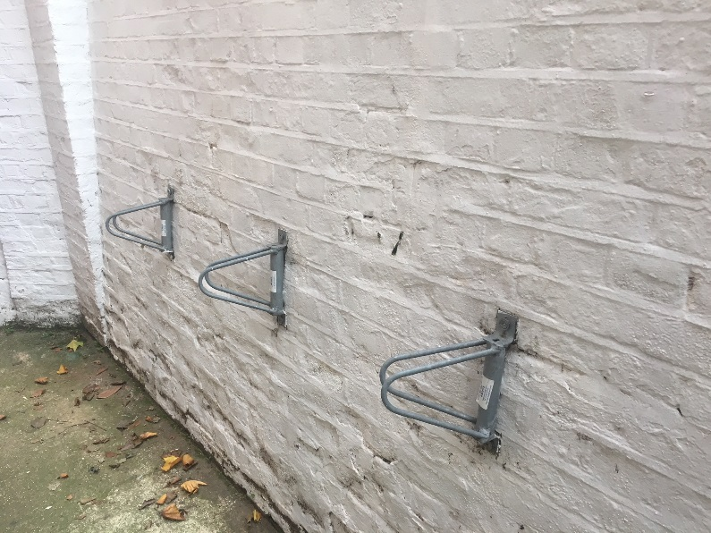

There is a covered scooter park which includes an additional cycle racks.
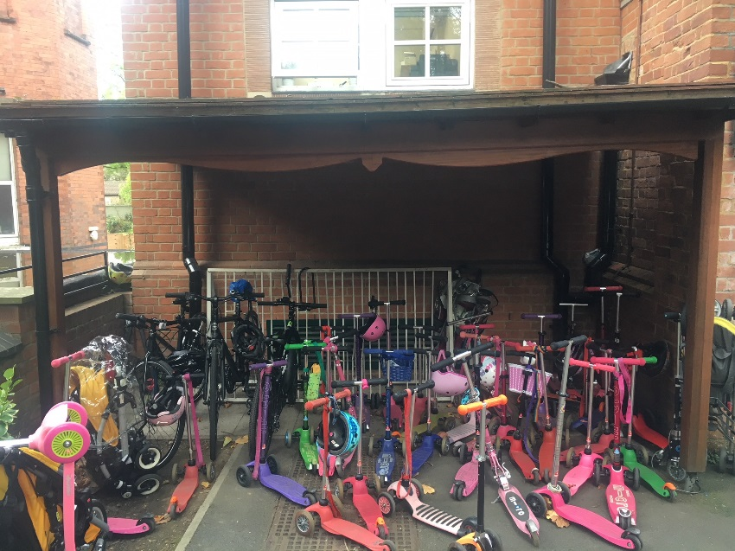

School transport facilities
Staff parking spaces: 4
Disabled parking space: 1
Visitor parking spaces: 5
Staff shower facilities: Yes
Coach parking facilities: No

Other travel information
Very few children or staff cycle to school as the roads are deemed to be too dangerous by parents. It is difficult to use the pavements as there are a huge number of children walking to school. Also, in certain parts the pavements are very narrow. To encourage cycling, proper, safe, segregated cycle lanes (not green paint on the roads) need to be provided throughout Hampstead and Belsize Park.

Travel Surveys

2019-20 | Pupil |  | Staff
Mode
 | Usual | Preferred | Usual | Preferred
Park and Stride - (5 minute walk plus) | 23 | 5
Car share (with non family members) | 5 | 15
Car (Including motor cycle) | 66 | 15 | 2 | 2
Rail/Overground | 8 | 6 | 5 | 2
Tube | 21 | 11 | 13 | 6
Public Bus | 19 | 10 | 3 | 1
Zeelo Bus | 6 | 7
Cycle | 3 | 43 |  | 1
Buggy | 4 | 3
Scooter | 39 | 36
Walking | 63 | 37 | 8 | 6
Total | 257 | 188 | 31 | 18

2018-19  Mode | Pupil |  | Staff
 | Usual | Preferred | Usual | Preferred
Park and Stride - (5 minute walk plus) | 17 | 2 | 1
Car share (with non family members) | 4 | 9
Car (Including motor cycle) | 41 | 20 | 1 | 1
Rail/Overground | 7 | 4 | 4 | 2
Tube | 9 | 1 | 11 | 4
Public Bus | 28 | 12 | 3 | 2
Cycle | 4 | 25 | 1 | 1
Buggy | 4 | 2
Scooter | 35 | 26
Walking | 80 | 31 | 5 | 4
Total | 229 | 132 | 26 | 14

2017-18  Mode | Pupil |  | Staff
 | Usual | Preferred | Usual | Preferred
Park and Stride - (5 minute walk plus) | 22 | 10 | 1
Car share (with non family members) | 11 | 11 |  | 1
Car (Including motor cycle) | 62 | 47 | 1 | 2
Rail/Overground | 10 | 8 | 3 | 1
Tube | 8 | 3 | 11 | 11
Public Bus | 11 | 6 | 4
Cycle | 1 | 23 | 1
Buggy | 3 | 3
Scooter | 25 | 27 |  | 1
Walking | 69 | 36 | 7 | 6
Total | 222 | 175 | 28 | 22

2016-17  Mode | Pupil |  | Staff
 | Usual | Preferred | Usual | Preferred
Park and Stride - (5 minute walk plus) | 21
Car share (with non family members) | 3
Car (Including motor cycle) | 66
Rail/Overground | 11 |  | 3 | 3
Tube | 15 |  | 9 | 9
Public Bus | 15 |  | 3 | 3
School Bus/Taxi | 1
Cycle | 1 |  | 2 | 2
Buggy | 1
Scooter | 16
Walking | 105 |  | 1 | 1
Total | 255 | 0 | 18 | 18

2011-12  Mode | Pupil |  | Staff
 | Usual | Preferred | Usual | Preferred
Park and Stride - (5 minute walk plus) | 5 | 0 | 11 | 1
Car share (with non family members) | 12 | 1 | 2 | 3
Car (Including motor cycle) | 70 | 5 | 1 | 5
Rail/Overground | 4 | 4 | 13 | 6
Tube | 0 | 0 | 0 | 0
Public Bus | 26 | 8 | 5 | 4
School Bus/Taxi | 0 | 0 | 0 | 0
Cycle | 1 | 0 | 3 | 7
Buggy | 0 | 0 | 0 | 0
Scooter | 0 | 0 | 0 | 0
Walking | 103 | 69 | 8 | 17
Total | 221 | 87 | 43 | 43

Current activities
Walk to school week: This has been completed each year since 2016-17 and will run again in 2019-2020. Each class monitored how the children came to school and all children were encouraged to walk to school or walk part way to school. Parents were informed. The Headmistress took part in a charity walk around the London and a walk from London to Brighton to inspire the children to walk to school. Staff also walked to school. The children completed activities in Drama, Music, Art and Science to promote walking to school.

Year 5 Life skills day: This was introduced in 2016-17 and ran again in 2017-18. It is very successful so will run again 2019-20. The children are taught how to cross roads safely and to use public transport. They use the tube from Hampstead to Belsize.

Visit to Houses of Parliament: This was completed in both 2016-17,2017-18 and 2018-19 and will run again 2019-20. The children use public transport and are taught how to use the tube and read a tube map to travel.

Local walks: Children from PN to Y6 will go on local walks around the school. How to walk safely and cross roads safely is encouraged.

School Councils: Discuss ways to encourage reduction of car usage.

Scooter training: For children in PN-R completed scooter training.

Proposed activities

Road safety week: For an assembly to be completed on road safety and other activities.

Life skills day: To include using the bus during life skills day.

Poster competition: To encourage walking to school.

