Travel Plan
2021-22

School Details

St Mary’s School
47 Fitzjohn Avenue
London
NW3 6PG
Tel: 0207 4351868
Email: office@stmh.co.uk

Headmistress: Harriet Connor-Earl
Deputy Head: Philippa d’Aquino
Director of Studies: Martin Otter

Borough: Camden
DFE number: 202/6084
School type: Roman Catholic Independent Prep School
Age Range: 2years 9months – 11
Number of students: 220
Number of staff: 65

Catchment area
There are 89 children from NW3 area. 38 children live in NW6. 12 from NW8, 13 from NW2. And the remainder from other areas. See chart below.
Post code | Area | 2018 | 2019 | 2020 | 2021
N1 | Hoxton | 3 | 4 | 3 | 1
N10 | Muswell Hill | 2 | 2 | 2 | 0
N3&N2 | Finchley | 6 | 6 | 6 | 6
N5 | Islington | 4 | 3 | 3 | 4
N6 | Highgate | 3 | 4 | 1 | 2
N8 | Crouch End | 2 | 0 | 0 | 0
NW1 | Camden, Regents Park | 1 | 2 | 1 | 4
NW10 | Brent, Kensal Green | 6 | 5 | 6 | 3
NW11 | Barnet, Childs hill | 8 | 11 | 11 | 8
NW2 | Brent | 11 | 10 | 11 | 13
NW3 | Camden, Hampstead, Swiss Cottage, Primrose | 131 | 126 | 131 | 89
NW6 | Kilburn | 54 | 56 | 54 | 38
NW5 | Camden, Kentish Town | 8 | 11 | 6 | 3
NW1 | Barnet, Mill Hill | 0 | 0 | 0 | 0
NW8 | Westminster | 25 | 23 | 25 | 12
N7, N11, N12, N17 |  |  | 4 | 3 | 0
NW9, SE3, W1U, WD3, HA4, I98 |  |  | 7 | 3 | 5
EC1Y, EC1R, EC4V | East London |  | 2 | 2 | 4
W9 | Westbourne, Westminster | 13 | 17 | 14 | 16

Expansion Plans
At present there are no expansion plans for the school. The school is open from 8am until 6pm each day. The school day runs from 8.45 until 4pm. There is a staggered dismissal time for children in R-Y6 between 3.30-4pm. Children from the Pre-Nursery and Nursery have the option of finishing at either 11:45, 12.30 or 3.30. There is an After School Club which runs from 4pm-6pm.

Bus Routes used by students and staff
82, 46, 603

Cycle Parking Facilities
There are three independent cycle racks.
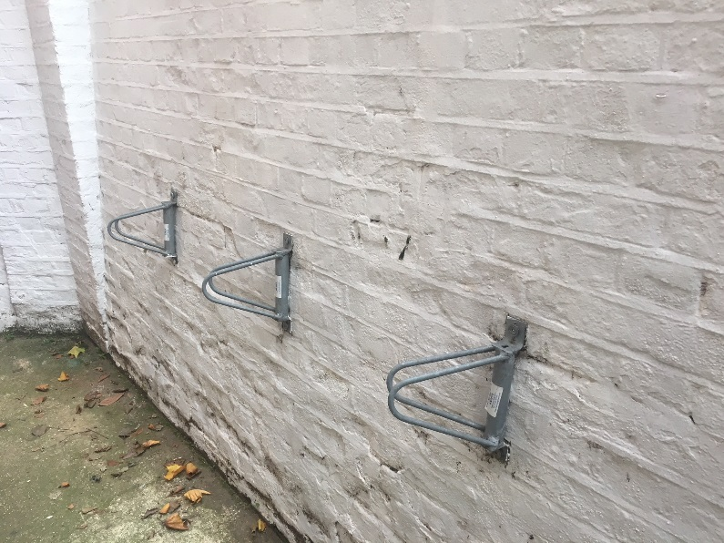

There is a covered scooter park which includes an additional cycle racks.
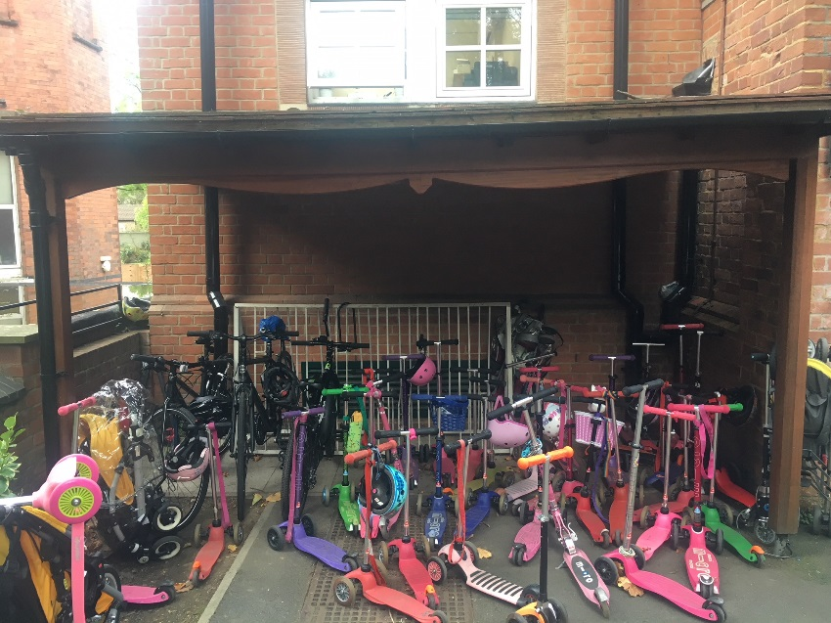

School transport facilities
Staff parking spaces: 4
Disabled parking space: 1
Visitor parking spaces: 5
Staff shower facilities: Yes
Coach parking facilities: No

Other travel information
Very few children or staff cycle to school as the roads are deemed to be too dangerous by parents. It is difficult to use the pavements as there are a huge number of children walking to school. Also, in certain parts the pavements are very narrow. To encourage cycling, proper, safe, segregated cycle lanes (not green paint on the roads) need to be provided throughout Hampstead and Belsize Park.

Travel Surveys
2021-2022 | Pupil |  | Staff
Mode
 | Usual | Preferred | Usual | Preferred
Park and Stride - (5 minute walk plus) | 22 | 17 | 4 | 4
Car share (with non family members) | 3 | 7 | 0 | 1
Rail/ overground | 4 | 6 | 9 | 5
Tube | 11 | 7 | 18 | 6
Public Bus | 11 | 12 | 8 | 8
Cycle | 8 | 56 | 2 | 7
Buggy | 3 | 4 | 0 | 1
Scooter | 21 | 40 | 1 | 1
Walking | 82 | 47 | 4 | 13
Car (not shared) | 46 | 25 | 6 | 6

Pupil responses
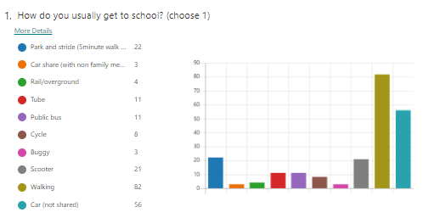

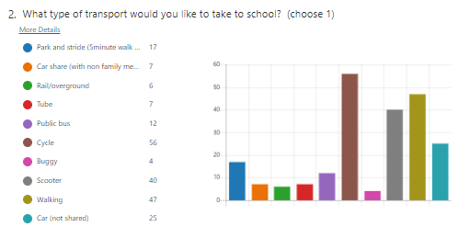
Staff responses

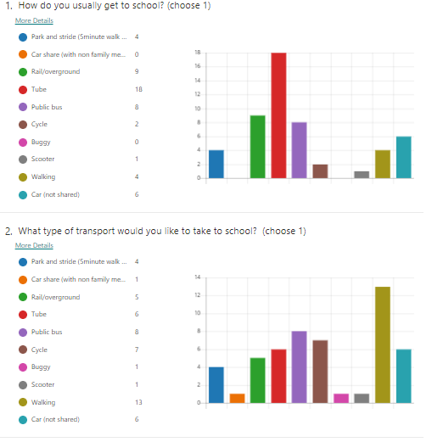

2020-2021 | Pupil |  | Staff
Mode
 | Usual | Preferred | Usual | Preferred
Park and Stride - (5 minute walk plus) | 8 | 5 |  | 1
Car share (with non family members) | 7 | 4 | 1 | 2
Rail/ overground | 3 |  | 5 | 2
Tube | 10 | 7 | 8 | 1
Public Bus | 4 | 4 | 2 | 1
Cycle | 3 | 47 | 1 | 6
Buggy | 6 | 3 |  | 1
Scooter | 17 | 27 |  | 1
Walking | 73 | 46 | 9 | 13
Car (not shared) | 60 | 41 | 8 | 7
Zeelo Bus |  | 6

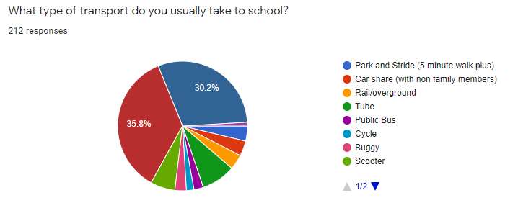

2019-20 | Pupil |  | Staff
Mode
 | Usual | Preferred | Usual | Preferred
Park and Stride - (5 minute walk plus) | 23 | 5
Car share (with non family members) | 5 | 15
Car (Including motor cycle) | 66 | 15 | 2 | 2
Rail/Overground | 8 | 6 | 5 | 2
Tube | 21 | 11 | 13 | 6
Public Bus | 19 | 10 | 3 | 1
Zeelo Bus | 6 | 7
Cycle | 3 | 43 |  | 1
Buggy | 4 | 3
Scooter | 39 | 36
Walking | 63 | 37 | 8 | 6
Total | 257 | 188 | 31 | 18

2018-19  Mode | Pupil |  | Staff
 | Usual | Preferred | Usual | Preferred
Park and Stride - (5 minute walk plus) | 17 | 2 | 1
Car share (with non family members) | 4 | 9
Car (Including motor cycle) | 41 | 20 | 1 | 1
Rail/Overground | 7 | 4 | 4 | 2
Tube | 9 | 1 | 11 | 4
Public Bus | 28 | 12 | 3 | 2
Cycle | 4 | 25 | 1 | 1
Buggy | 4 | 2
Scooter | 35 | 26
Walking | 80 | 31 | 5 | 4
Total | 229 | 132 | 26 | 14

2017-18  Mode | Pupil |  | Staff
 | Usual | Preferred | Usual | Preferred
Park and Stride - (5 minute walk plus) | 22 | 10 | 1
Car share (with non family members) | 11 | 11 |  | 1
Car (Including motor cycle) | 62 | 47 | 1 | 2
Rail/Overground | 10 | 8 | 3 | 1
Tube | 8 | 3 | 11 | 11
Public Bus | 11 | 6 | 4
Cycle | 1 | 23 | 1
Buggy | 3 | 3
Scooter | 25 | 27 |  | 1
Walking | 69 | 36 | 7 | 6
Total | 222 | 175 | 28 | 22

2016-17  Mode | Pupil |  | Staff
 | Usual | Preferred | Usual | Preferred
Park and Stride - (5 minute walk plus) | 21
Car share (with non family members) | 3
Car (Including motor cycle) | 66
Rail/Overground | 11 |  | 3 | 3
Tube | 15 |  | 9 | 9
Public Bus | 15 |  | 3 | 3
School Bus/Taxi | 1
Cycle | 1 |  | 2 | 2
Buggy | 1
Scooter | 16
Walking | 105 |  | 1 | 1
Total | 255 | 0 | 18 | 18

2011-12  Mode | Pupil |  | Staff
 | Usual | Preferred | Usual | Preferred
Park and Stride - (5 minute walk plus) | 5 | 0 | 11 | 1
Car share (with non family members) | 12 | 1 | 2 | 3
Car (Including motor cycle) | 70 | 5 | 1 | 5
Rail/Overground | 4 | 4 | 13 | 6
Tube | 0 | 0 | 0 | 0
Public Bus | 26 | 8 | 5 | 4
School Bus/Taxi | 0 | 0 | 0 | 0
Cycle | 1 | 0 | 3 | 7
Buggy | 0 | 0 | 0 | 0
Scooter | 0 | 0 | 0 | 0
Walking | 103 | 69 | 8 | 17
Total | 221 | 87 | 43 | 43

Current activities
Walk to school week: This has been completed each year since 2016-17. Each class monitor how the children come to school and all children are encouraged to walk to school or walk part way to school. Parents are informed.

Visit to Houses of Parliament: This was completed in 2016-20. The children use public transport and are taught how to use the tube and read a tube map to travel. This is unable to be completed at this time due to restrictions.

Local walks: Children from PN to Y6 will go on local walks around the school. How to walk safely and cross roads safely is encouraged.

School Councils: Discuss ways to encourage reduction of car usage.

Scooter training: Children in PN-R undertook scooter training during the 20-21 academic year.

